Project F.A.L.C.O.N.
Filming Autonomous Learning and Cinematic Optical Navigator

Thomas Murphy, CompE, Owen Raftery, CompE, Alexander Shikhanovich, CompE, and Anesti Zguro, CompE

Abstract—This project presents a machine learning-based approach to drone cinematography. Using computer vision, we aim to autonomously control a camera drone to ensure the desired subject remains reasonably within the frame while maintaining a consistent distance. Using a glove, we aim to allow the filmmaker to make camera adjustments without impeding the activity filmed.

INTRODUCTION

Modern camera drone systems can provide high-quality footage with impressive video stabilization, producing captivating and unique results. However, they require a designated and relatively experienced drone pilot, particularly in instances with rapid movement and athletic activity. Our goal is to create an autonomous drone control system that enables users to freely navigate their environment while capturing footage of themselves.

Significance
Aerial cinematography shots were originally achieved through shots using “...very expensive…[helicopters] or [small planes]” [1]. However, modern accessible drones “...[require] skillful piloting…” [1] and exist in the “price range [of] $1,500 to $3,000” [2]. making them unrealistic to use for low-budget or solo cinematography projects.

Context and Survey of Similar Solutions
This project addresses the need to film while performing activities that can be cumbersome to carry or mount a camera. Using drones allows a user to ditch handheld cameras and capture their footage. The main issue with drones is controlling their flight to track users and produce satisfactory footage, which is where autonomous flight systems are helpful. Autonomous cinematography is typically handled through either GPS tracking or DJI’s “ActiveTrack” [3] technology. As technology has advanced, so have these types of drones, but one aspect of the technology remains the same: manual controllers. While the autonomous tracking software in these drones is excellent at tracking users, when a user wants to specify an instruction to the drone (come closer, move to the front, etc.), they must use a handheld controller. This controller may take multiple forms, such as a typical RC remote or an app on a cell phone, but they are all intrusive or require a third party to control the drone. There are many examples of this seen in DJI’s lineup; their drones have excellent tracking systems, but still rely on a handheld controller to manually adjust the drone. The proposed solution in this project is to use a new form of controller for the drone. This controller is based on the user’s finger movement and will be designed as a non-intrusive, glove-like device. This will allow the user to make micro-adjustments to the drone without a bulky system or a third party to operate it.

Societal Impacts
The target audience for our prototype is athletes and amateur videographers in the sports/action-shooting niche. Our goal is to provide a more accessible, user-friendly option for filming moving targets in sports. This project not only provides a lower-cost alternative to the expensive drone rigs already on the market, but also removes the need for a drone pilot. This allows content creators and athletes to more easily and reliably produce footage of their hobbies and activities. Keeping this target audience in mind, our design priorities were ease of use, lightweight wearable controls, and project runtime. The inclusion of machine learning enables a completely autonomous process. A controller weighing under 300 g that preserves finger dexterity enables device use across a variety of movement activities. Our goal is to ensure the product lasts the entire duration of solo-sport activities, allowing the user to capture the entire session on a single charge.

Goals, Specifications and Testing Plan

Spec | Purpose | Method | Goal | Justification
Total  Operation  Time | Define estimated system operation time | Time drone battery lasts is while device is tracking and airborne | Flight and Tracking able to be sustained for 8.5 minutes | Sasha Ski Runtime: 7.33 mins avg.  Owen Climb Time: 2-3 mins avg.  Average bike/skateboard campus commute: 8 mins
Component  Separation | Determine the optimal spacing between all system components | Move drone and glove outward from base station until signal is lost, and record distance | Signal loss occurs at no less than 50 ft | Target use case does not require distances >50 ft
Speed | Determine maximum speed for accurate tracking | Test framing at increasing object movement speeds; fail if out of frame longer than 5 seconds | The drone maintains center-frame alignment at subject speeds up to 10 mph | Aligns with the speed at which our target activities are performed (pace is slow-moderate for skiing, park runs)
Delay | Define estimated system delay time | Log & Average delay time of each component | Drone adjusts movement no later than 1.5 seconds after movement occurs | 1.5 seconds of not in-center framing is reasonable for quality action camera footage
System Weight | Define the total weight of the glove match standard keep glove light and useable | Place finished glove controller on scale | Place finished glove controller on scale | 300g, matches video game controller weight
System Cost | Keep estimated production cost of device competitive with market equivalent | Find what final systems specs would cost during production in bulk by examining supplier sites | Find what final systems specs would cost during production in bulk by examining supplier sites | ~$350, matches budget equivalent drone on the market
Signal Send Fail Rate | Determine the amount of dropped / unacknowledged packets from glove | Log all sent / received packets, divide total received by base station by total sent to find completion percentage | Log all sent / received packets, divide total received by base station by total sent to find completion percentage | <25%, sufficient to maintain smooth tracking given fast, near continuous, transmission rate

Table 1: Specifications and Testing Plan

Design

Overview
We plan to use a three-tier architecture in order to solve the problem. We will use Wi-Fi as the primary communication method between these three components. Our methodology revolves around a base-station computer that will handle signal processing and computation. The two external components will be the camera drone itself and a wearable glove controller for fine-tuning drone movements. Initially, the drone will be launched into the air, and its video signal will be streamed to the base station for processing. The base station will use a fiducial tracking algorithm to identify the target in each video frame. A model will be trained to identify fiducials (QR codes) that are placed on the object. The base station will perform the algorithm and compute movement metrics to keep the drone in the desired dreaming. Last, these metrics are sent to the drone as instructions to perform. Additionally, the base station will take the user's glove controller movement signals into account when instructing the drone. This means the user can manually adjust the drone's position, deviating from the algorithm's suggestions, according to their preferences. These manual inputs will be combined with the algorithm-generated instructions and transmitted back to the drone over Wi-Fi to execute movement commands. For alternative designs and tradeoffs, see Appendix A. The technologies and standards used in this project are outlined in Appendix B. The hardware block diagram is illustrated in Figure 2 and described in the hardware block section. The software block diagram is illustrated in Figure 3 and described in the software block section.

Hardware Block
The hardware design of this prototype centers on creating a wearable, glove-like controller for inserting user instructions into what is otherwise an autonomous flight system. The main hardware components in this design are a DJI Tello drone [5], a Jetson Orin Nano Super [6], and a custom controller built with custom hardware and an ESP32-S3 [7] microcontroller. The Jetson Nano connects to the glove using TCP and to the drone using the UDP protocol, using separate 2.4 GHz WiFi connections. Using the on-board and an additional purchased WiFi card [8], the Jetson Nano acts as a middleman, or more commonly known as a “base station,” in this project, handling all data transmission between the controller and the drone. The Jetson Nano is the main processor in the prototype, handling frame processing of frames received from the drone to locate and track the target.
The glove controller is designed to fit a user’s hand without being overly invasive, allowing them to participate in activities and control the drone simultaneously. The design currently uses generic 3-state switches to read input from each finger on the user’s hand. The ESP32 sends their states to the base station, where they are translated into instructions. These instructions are sent to the Jetson Nano over Wi-Fi; the controller then resumes listening for more instructions from the user.
The last of the main hardware components is the DJI Tello. This is an off-the-shelf product acquired with funds provided by the ECE Department for this project. This drone was purchased because of its popularity for projects like this one. The drone comes with on-board WiFi, making UDP the most efficient way to communicate between the Jetson Nano and the drone.
To test this block, communication links between components have been established, and SYN/ACK signals are sent to test connectivity. To test the actual performance of the hardware, visual confirmation on both a monitor and in real life of the drone receiving commands and following the instructions confirms a working relationship between the different components in the hardware block of this prototype.
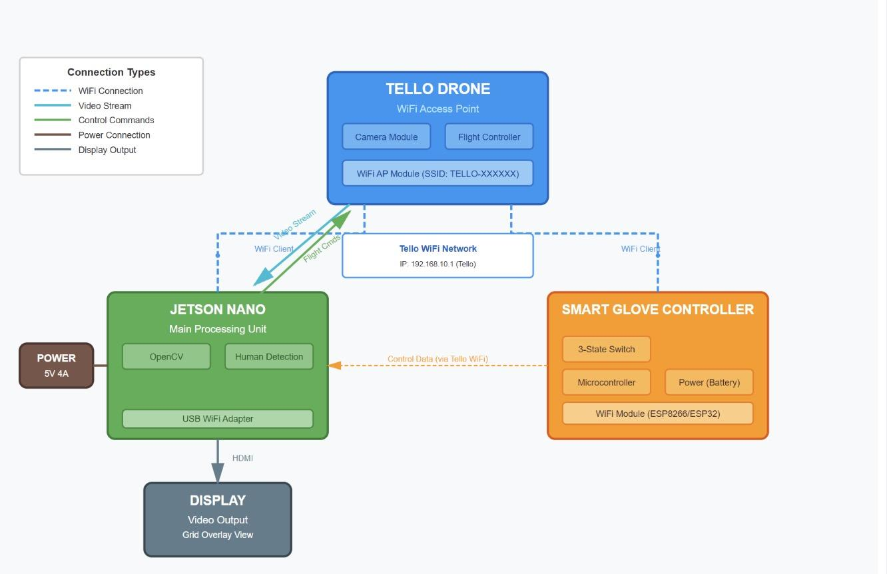
Figure 2: Block diagram depicting the design at a hardware level.

Software Block
The software part of this project is the most complex part of this system. It involves a strong feedback loop between the drone and the base station. Frames from the drone are sent to the base station, where a computer vision algorithm analyzes each frame to find the target. The algorithm determines where the target is located within a grid on the screen and whether any adjustments are needed to center it. The next task for the algorithm is to determine the target’s distance from the drone, then make the appropriate adjustments to keep the target within the desired tracking range. After these adjustments are calculated, they are relayed back to the drone from the base station. While all of these calculations are taking place, the glove controller is listening for physical input from the user. When input is detected, they are sent to the base station to be translated from states into instructions for the drone. The base station then appends these instructions to the algorithm's instructions and sends all information to the drone at once.
To build this block, knowledge of machine learning algorithms and computer vision was necessary to detect the target and center it on the screen. For programming the drone, an SDK from DJI [9] is used to communicate with the drone (DJI Tello) due to its extensive documentation and easy-to-use Python library. Both of these skills were learned in classes throughout college. To communicate between the drone, controller, and base station, some computer networking skills were learned. These skills include learning to program WiFi cards to be in Access Point mode, UDP/TCP networking protocols, and creating a server/client behavior schema.
To test this block, a series of test flights have been performed. These flights tested our software's design step by step, starting with getting the drone up in the air and flying via keyboard input. The next tests involved capturing drone footage and tracking an object, then sending instructions to the drone to turn and keep the object centered in the frame. Next, we tested the computer vision algorithm’s performance by using it to send instructions to the drone to follow a target. Once this test was performed, we tested the glove by having it send instructions to the drone for simple commands, such as moving closer/farther away from the target.
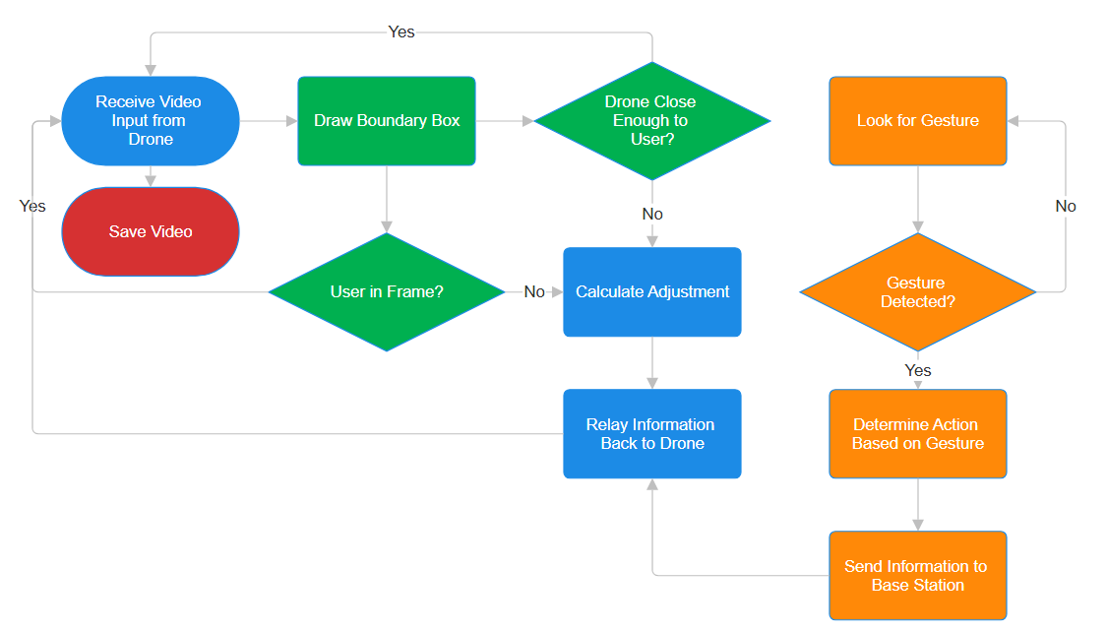
Figure 3: Block diagram depicting the program flow of the design’s software.

The Prototype
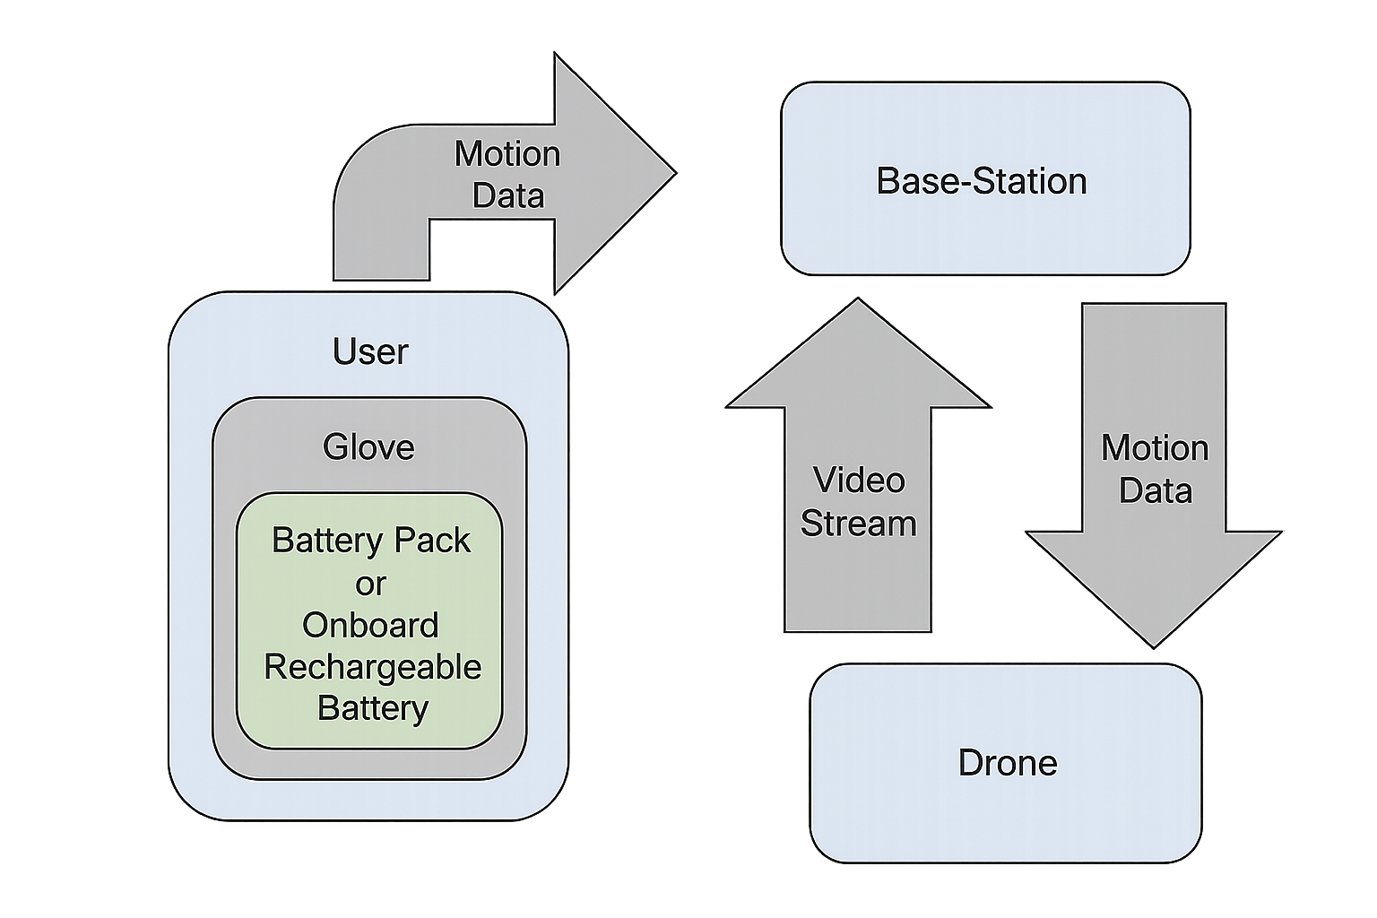
Figure 4: Block diagram Overall System Design

A. Prototype Overview
The prototype of this project is a drone that supports fully autonomous target tracking with manual override for different camera configurations. As shown in the diagrams, the hardware consists of the Jetson Nano, smart glove, and a drone. The Jetson Nano runs a constant machine-learning-based target-tracking algorithm. The footage passed to the Nano will be processed frame by frame. Each frame is segmented into a three-by-three grid and the algorithm's goal is to determine the movement instructions required for the drone to stay in the center box. To accomplish this the algorithm is trained to recognize fiducials (custom QR codes) placed on the object to track. By utilizing the position of the fiducial in the frame and its size, the algorithm generates movement instructions for the drone to complete in order to keep the target center frame. The Jetson then sends those commands to the Tello. This loop constantly runs unless interrupted by the smart gloves' non-neutral states, telling it to film from closer or farther back for different angle captures. This is communicated through hand contractions which trigger the three-state switch, and the on-board wifi module of the glove's microcontroller. After the state of the glove goes back to neutral, the loop continues with the target tracking.

B. List of Hardware and Software
    - Hardware
      - NVIDIA Jetson Orin Nano Super Developer Kit
      - DJI Tello
      - ESP32 S3 Developer Board
      - 3-state toggle switches
      - Glove integrated custom PCB
      - Battery pack
    - Software
      - Docker
      - Python
        - OpenCv
        - Djitellopy
      - C++
      - Ubuntu

C. Custom Hardware
Our hardware design consists of a smart glove controller, a Jetson Nano, and the DJI Tello drone. Starting with the smart glove, it is made with 3-state switches which refer to values of -1, 0, or 1. The switches are activated with a finger and are programmed to insert the user’s commands into the autonomous flight algorithm. The switches currently rest on the side of a breadboard, but are eventually going to be integrated into a glove-like design facing inwards, towards the palm of the user’s hand. The switches are read by the microcontroller on the back of the user’s hand/wrist. The microcontroller, an ESP32-S3, will send the states of the switches to the Jetson Nano. From there the Nano will interpret the states and send commands to the DJI drone. There will need to be a battery powering the microcontroller and switches integrated into this design. Currently, this is done via a portable battery back. But, eventually, this will require a power management system in order to limit the voltage and current put into the system by the battery. The power management system will be a custom design using a voltage regulator that will extend the controllers battery life as it limits the current draw on the battery.
This custom design will include test points for comparing the voltage and current in/out of the power management system. These measurements will be used to calculate an estimate of the controller’s battery life. This battery life should exceed, at a minimum, the drone’s average flight time.
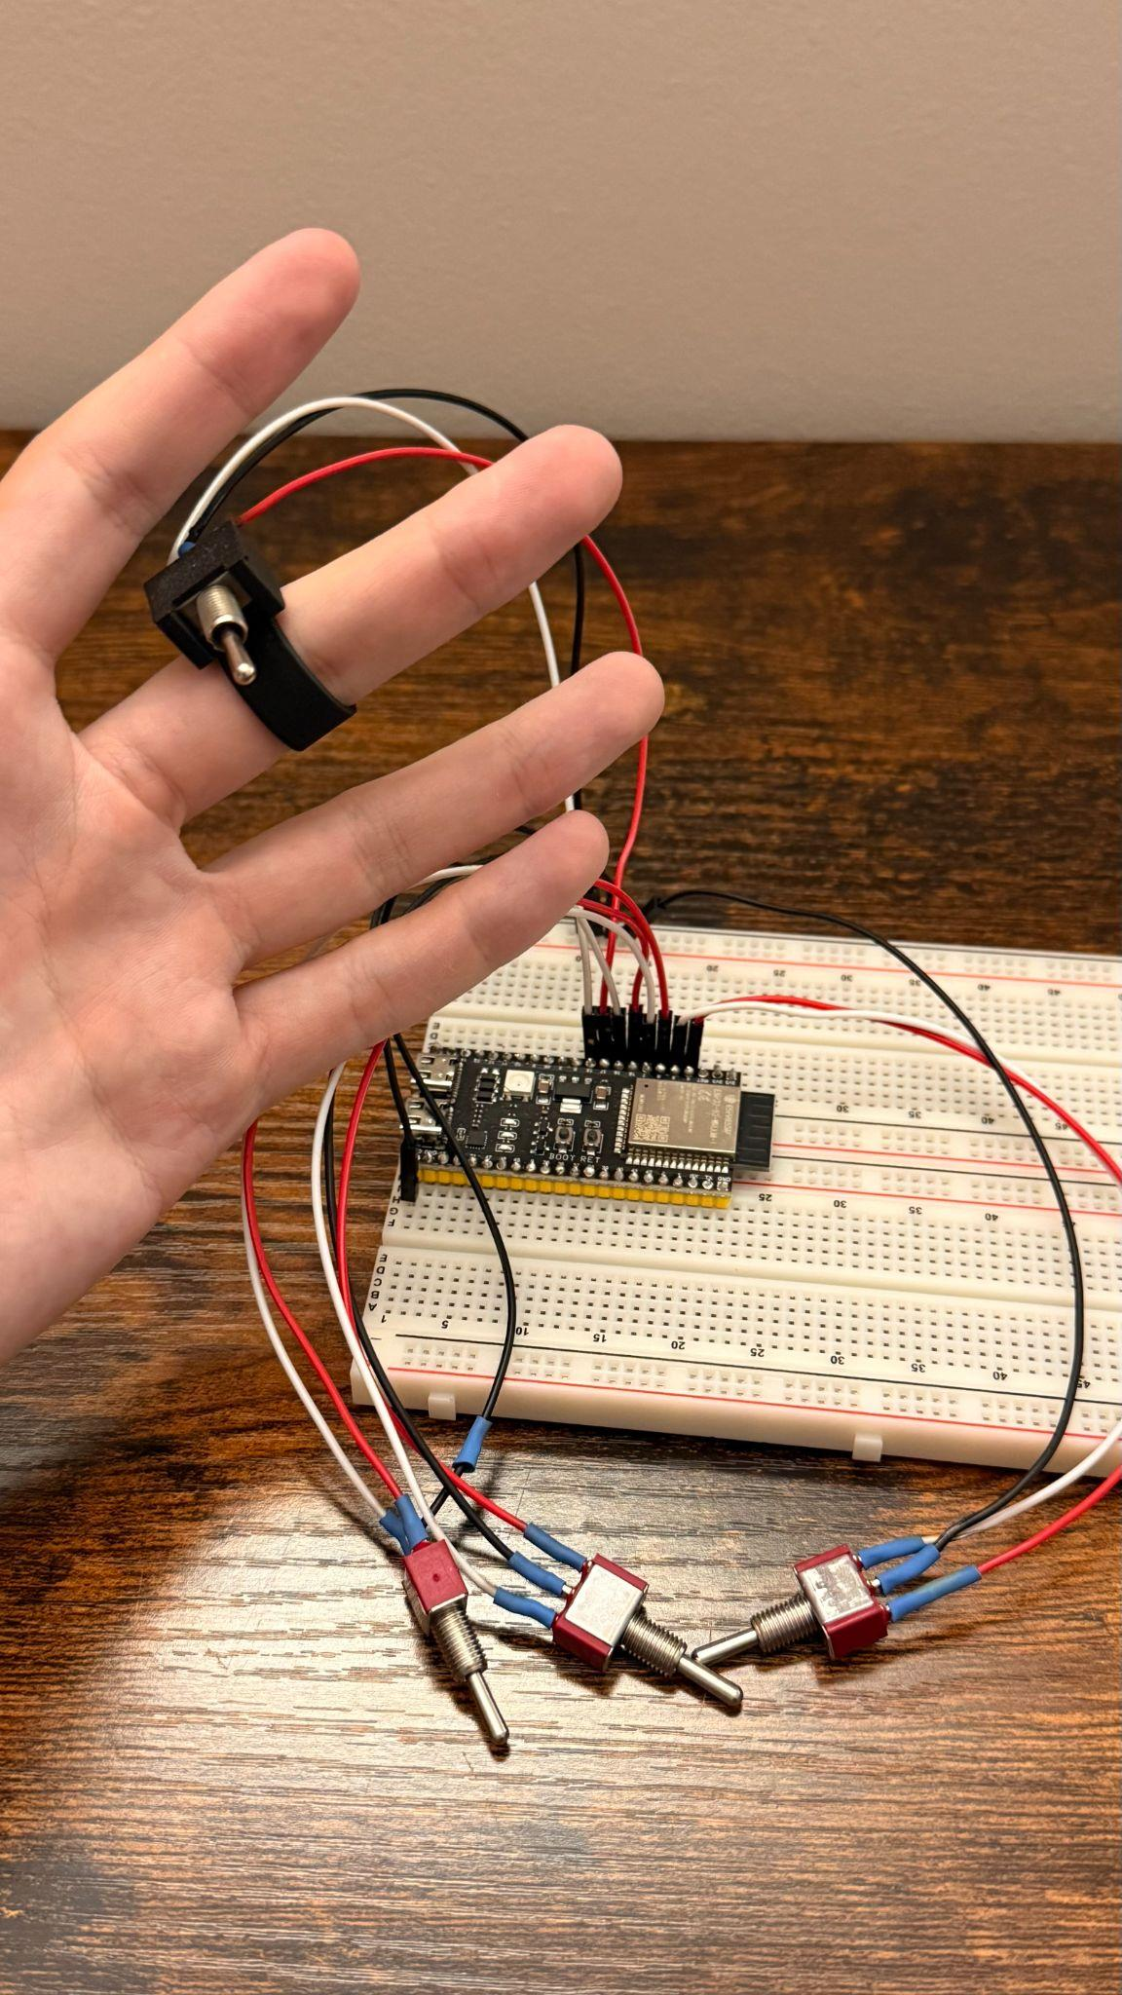
Figure 5: Breadboarded Design and Finger-mounted Switch Casing
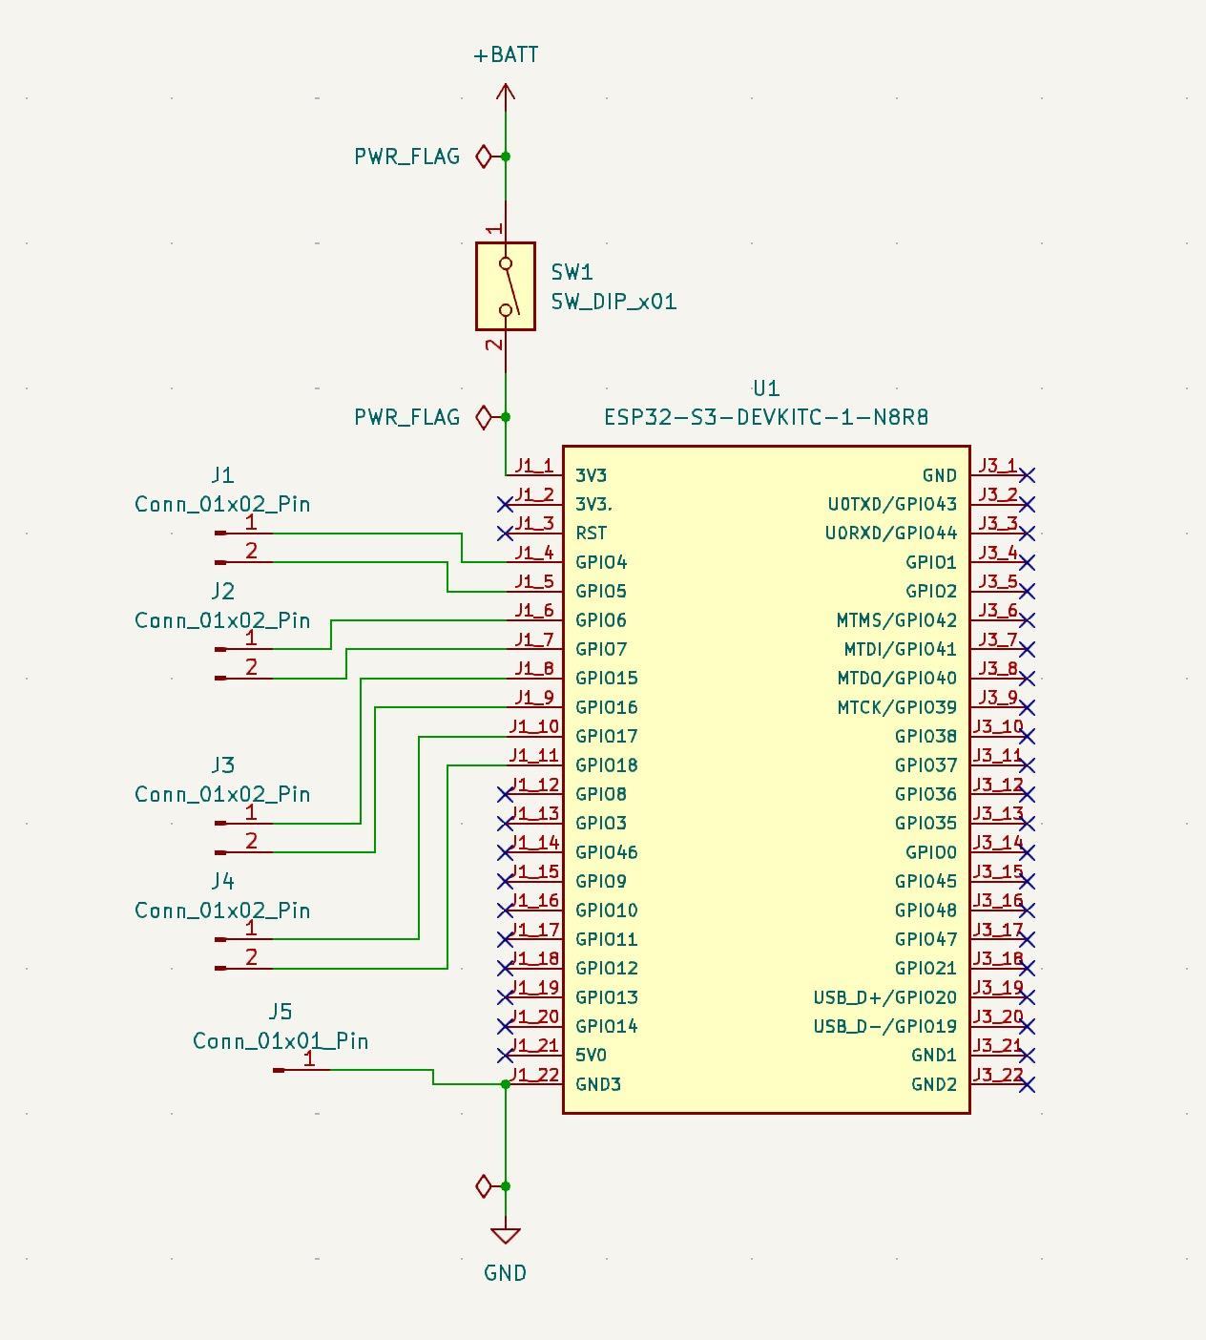
Figure 6: Current Project Schematic
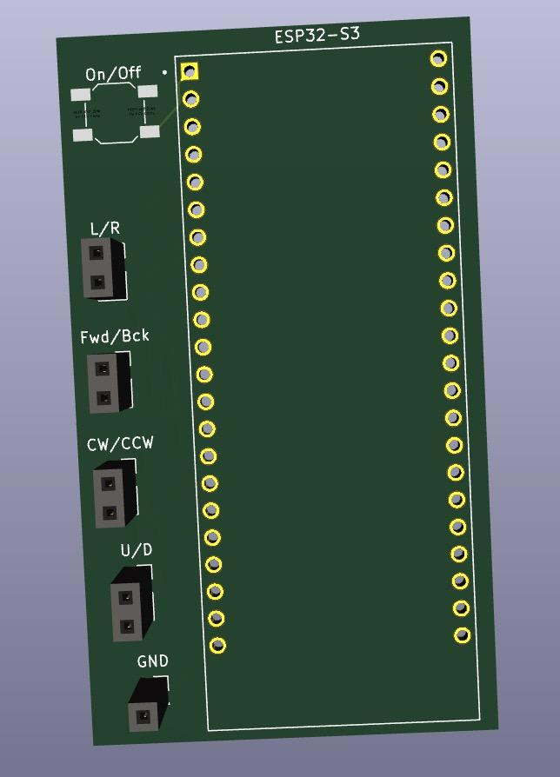
Figure 7: Current Project PCB
D. Prototype Functionality
In the development stage of this prototype, all components on the block diagram have been tested together and are all working as part of a complete system. The Jetson Nano has been used to connect to the drone and send commands to make the drone do simple movements (forwards, turn, backwards, etc.). Separately, on a laptop, the drone has been fed instructions from a computer vision model to have the drone track an object. The drone was able to successfully keep the target in the center of the frame, using up, down, turn left, and turn right instructions. The algorithms, which can run either on the Jetson Nano or on a laptop, makes the drone fully autonomous and capable of tracking and following users as they move freely through space.
The glove controller has been designed and programmed, but will be redesigned in order to create a more intuitive and less obtrusive method of drone control while use during sports and other activities. The controller is capable of reading a three input (-1, 0, 1) from each finger on the user’s hand, with each finger being associated with a different instruction for the drone (fly left, up, closer, etc.). The the server-client relationship between the Jetson Nano and the ESP32 that is used for processing on the glove has also been completed and tested. Once instructions are sent from the glove to the controller, the instructions are fed into the stream of commands generated by the autonomous tracking system and sent to the drone, as seen in Figures 3 and 4.
E. Prototype Performance
Currently the project is still in its design phase and only limited, qualitative and performance tests have been conducted as the project has progressed. Once the project has hit a stage where it has moved from general performance development to optimization , tests will be performed on flight time, controller weight, latency, component separation, and acknowledgement responses from the drone after commands are sent. Details for these tests are outlined in table 1 above.

Conclusion

The project is at the stage where all components of the system are communicating with one another. The base station is able to receive the video stream from the drone and process the information into movement commands using computer vision. It is also able to receive movement signals from the glove controller and provide adjustments to the drone’s movement based on those inputs. The next steps will be to create and test the next iteration of the glove controller, optimize the computer vision algorithm for faster and more reliable motion adjustment, and to include safety procedures to avoid mishaps during flight.
Acknowledgment
We’d like to thank CTEH for donating the NVIDIA Jetson Orin Nano Super Developer Kit. Additionally, we would like to acknowledge the contributions from the UMass M5 ECE makerspace for supporting various prototyping tasks.

References
- Z. Fahmy, “Making movies in the air: Adapting traditional storyboard techniques to drone film and virtual reality (VR),” Norsk medietidsskrift, vol. 31, no. 2–3, pp. 1–12, 2025. doi: 10.18261/nmt.31.2-3.8.
- UAV Coach, “How much does a drone cost? Drone prices by type for 2025,” Drone Pilot Ground School, Oct. 13, 2025. [Online]. Available: https://www.dronepilotgroundschool.com/how-much-does-a-drone-cost/. [Accessed: Oct. 26, 2025].
- J. Flynt, “What is DJI ActiveTrack and how does it work?,” 3D Insider, Feb. 19, 2019. [Online]. Available: https://3dinsider.com/dji-activetrack/. [Accessed: Oct. 23, 2025].
- G. Jocher et al., “Ultralytics YOLO11,” Ultralytics YOLO Docs, Sep. 30, 2024. [Online]. Available: https://docs.ultralytics.com/models/yolo11/. [Accessed: Oct. 26, 2025]
- “Tello – Drone & Accessories – DJI Store,” Dji.com, 2020. [Online]. Available: https://store.dji.com/shop/tello-series. [Accessed: Oct. 26, 2025]
- “Jetson Orin Nano Super Developer Kit,” NVIDIA, 2025. [Online]. Available: https://www.nvidia.com/en-us/autonomous-machines/embedded-systems/jetson-orin/nano-super-developer-kit/. [Accessed: Oct. 26, 2025]
- “ESP32-S3-WROOM-1-N16R8 | DigiKey Electronics,” DigiKey Electronics, 2025. [Online]. Available: https://www.digikey.com/en/products/detail/espressif-systems/ESP32-S3-WROOM-1-N16R8/16162642?gclid=9d1c017e145110f62f736980d36b2c91&gclsrc=3p.ds&msclkid=9d1c017e145110f62f736980d36b2c91. [Accessed: Oct. 26, 2025]
- “Geekworm NVIDIA Jetson Nano Dual Band Wireless USB 3.0 WiFi Adapter 5GHz+2.4GHz 1200M,” Geekworm, 2025. [Online]. Available: https://geekworm.com/products/geekworm-nvidia-jetson-nano-dual-band-wireless-usb-3-0-adapter-5ghz-2-4ghz-1200m. [Accessed: Oct. 26, 2025]
- “Tello - DJITelloPy API Reference,” [Online]. Available: djitellopy.readthedocs.io. https://djitellopy.readthedocs.io/en/latest/tello/. [Accessed: Oct. 26, 2025]

Appendix

Design Alternatives
An alternative approach we considered was to use a cheap generic drone in combination with a self-programmable flight controller. We considered drones in the $6 to $20 range combined with capable flight controllers typically in the $75 to $90 range. Additionally, we would have to mount a camera to the drone with a microcontroller to interface with the flight controller, which would actively communicate with the Jetson Nano. Similar to our current design, the Jetson Nano would handle converting computer vision and glove input to flight controls, but instead, would send commands to the flight controller rather than the drone directly. The glove design is the same as our current solution. We found some advantages and disadvantages to this design alternative.
Advantages:
  - Cheaper Drone
  - Greater potential for learning about flight hardware, communications tech, dealing with signal noise/cleaning
Disadvantages:
  - Expensive Flight controller
  - Need to program/test/calibrate flight controller
  - Need for self-built communications schema
  - More roadblocks prior to getting M.L. integration
In the end, we scrapped this alternative because the price of a cheap drone with a flight controller was incredibly close to our current solution’s drone, but the DJI Tello does not require programming, testing, and calibration of a flight controller or communication schema. In other words, our current approach is a small price increase for a large decrease in overhead.

Technical Standards
- IEEE Standard: 1003.1 POSIX
  - Defined as compatibility for system interfaces, commands, and utilities that guarantee portability and reliability of software across systems
  - Our examples:
    - Ubuntu
      - Unix-like operating system, meaning it follows the standardized set of operating system interfaces as defined by the standard
    - Python
      - Programming language with interpreter utilizing standardized APIs and libraries as defined by the standard
    - Docker
      - Organizes standardized, isolated environments to ensure consistent behavior across systems as defined by the standard
- IEEE Standard: IEEE 802.11 WiFi
  - DJI Tello
    - Reception of flight commands and sending of video through WLAN communication as defined by the standard
  - Jetson Nano
    - Can transmit and receive data through WLAN as defined by the standard
  - ESP32 Microcontroller
    - Can transmit and receive data through WLAN as defined by the standard
- ISO/IEC 14882 (C++ Standard)
  - C++’s language syntax, libraries, and behavior follows the standard’s definitions
- FCC Part 15
  - Defines standard for unlicensed operation, emission limits, and frequency interference responsibility
  - All WiFi connect components must follow this standard

Testing Methods
So far, the experiments that we have designed and executed have been drone commands and object tracking. For drone commands, we simply consulted the drone SDK documentation and wrote various scripts to test each command's functionality, as well as play with parameters that adjust speed and distance. For example, we would make a script that connected to the drone, simply do a spin and land. We found the drone was receptive to every command and completed actions as instructed very exact. This test was focused on the drone hardware as well as the Jetson to see how easily they could connect and communicate through wifi as shown in the diagrams.
After testing single commands we tested how the drone handled sequential commands by making scripts with a certain sequence of commands. The drone would have to hit certain distances and turn degrees at every command, and we would see when it would timeout or simply not follow commands. For example a twenty instruction sequence where if it followed exactly what we made it do, it would land at this X in the room. In this experiment we found that sometimes the drone would overload and simply land due to time out errors, like if it had a long sequence of commands and low battery. We also deduced there was always a bit of drift when flying since everytime we ran the same sequence from the same spot, it would finish in different places with an eight to twelve inch drift. This was another test of the drone and how exact it is at following directions given by the Nano.
Moving to the computer vision testing the first test we had run was a color tracking test. We tapped into the stream of the drone and overlaid a three by three grid on the screen. In this algorithm a box was drawn around an object with the target color and if it landed in eight of the nine boxes the Nano would send a command to the drone to center the object back into the middle box. In this test we found in a controlled environment of light that when the drone was above 15% battery it was very good at tracking the object. When under 15% the drone would timeout frequently. This experiment gave us the knowledge of when battery life affects machine learning performance and that the drone was very exact at object tracking. This tested the algorithm of our diagram as well as Jetson and drone communication.
Testing the handheld controller will consist of an onboard confirmation that each switch’s signal is being received. This will be confirmed via changes to the LED colors onboard the ESP32, which changes upon signal reception from the switch. Another test will be performed to ensure that the base station is receiving the commands sent by the handheld controller. This will be done by monitoring the packet transmissions on the base station, and examining the signal stream for packet loss.

Project Expenditures

Item | Unit Cost | Quantity Purchased | Total Cost
DJI Tello Drone | $89.85 | 2 | $179.70
3x ESP32 S3 | $19.82 | 1 | $19.82
MPU-6050 6-DoF Accelerometer | $12.95 | 1 | $12.95
Jetson Orin Nano Super | $273.00 | 1 | $273.00
10x Three-State Switch | $48.67 | 1 | $48.67
Jetson case with fan | $22.99 | 1 | $22.99
10x Potentiometers | $0.99 | 1 | $0.99
Power Regulation PCB | $100.00 | 1 | $100.00
WiFi Network Card | $18.89 | 1 | $18.89
DJI Tello Batteries | $35.98 | 1 | $35.98
TOTAL |  |  | $712.99

Note that the cost detailed here are a combination of current spending from the SDP budget as well as the total value of items that were donated to the group / sourced from the M5 makerspace. The cost of components donated / sourced from M5 is $334.62, while the components cost purchased with SDP Budget is $378.37

Project Management
Our team is organized around each member’s strengths. Sasha handles controller design, documentation, and planning, leading work on the glove hardware and custom PCB. Tommy manages the base station and communication setup, building the Wi-Fi network that connects the Jetson Nano, glove, and drone. Owen and Anesti focus on computer vision, developing object-tracking models to keep targets centered at a set distance. Owen and Anesti collaborate closely on software, while Sasha and Tommy coordinate hardware research and integration. Tommy often bridges the two sides through his work on the Jetson Nano. We communicate daily through text and Discord to stay aligned. Tommy and Sasha showed leadership through early hardware research and planning, and Anesti led initial hardware acquisition with the Jetson Nano.

Beyond the Classroom
Thomas Murphy:
For this project, I have had to learn and develop several skills. I have needed to expand upon some basic networking skills that were obtained in the classroom in order to create a server-client relationship between the Jetson Nano and the controller. I also needed to learn how to create and use Docker environments in order to manage dependencies between the multiple different environments that the software is being run on (different laptops, Jetson Nano). I have found that online forums like Stack Overflow and Reddit have been helpful for creating Docker env ironments, and AI tools/different Python and C++ documentation pages have been helpful for learning how to network the different components in this project.
Owen Raftery:
I have needed to develop knowledge and skills on drone cinematography, computer vision, and docker. I found other projects Youtube and GitHub to be great resources for learning how computer vision and drones interface with each other. Beyond that, generative AI has been the best tool for further learning on implementing computer vision through code as well as learning Docker syntax and putting it into context with our project.
Sasha Shikhanovich:
For this project, I’ve needed to further my understanding of embedded system design and programming, systems engineering, and CAD. To accomplish this, I have followed several tutorials on the Adafruit website for programming hardware with the ESP32-S3. I have also revisited the guides on KiCad and Onshape’s websites to complete the finger fixture and schematic designs. YouTube and other AI tools have also been incredibly helpful for research and understanding how the glove controller hardware will be integrated into the rest of the system. Much of this work builds on my past experience in systems engineering and in building microcontroller-based data-logging prototypes. I am also expanding my knowledge into more hardware- and computer-networking-focused sub-disciplines that I hope to explore further in my career. Moving forward, much of my efforts will be focused on developing the hardware, furthering my need use CAD software.
Anesti Zguro:
During this project I have needed to understand a strong foundation of Open-Cv, Ultralytics, and Docker/Jetson containers. Due to this project needing heavy GPU support we found lots of mismatch in versions and dependencies needed for certain libraries. GitHub, AI, and Youtube have been a wealth of knowledge for me, learning everything I needed to know about docker and the Jetson, and finding examples of how other people applied machine learning into their own projects. My profession as of now fully aligns with every one of these skills as machine learning is a huge factor in a lot of work projects as well as robotics programming.

